Mario Bolivar

Mjb160330

CE 3345.001

Professor Chida

Assignment 1

1. **Write a recursive method in pseudo code that returns the number of 1’s in the binary representation of N. Use the fact that this equal to the number of 1’s in the representation of N/2, plus 1, if N is odd.**

recBinary(int number)

calls recBinaryHelper(int number, int sum) 🡨 sum will be 0 when called from recBinary

If (number % 2 != 0) 🡨 if number is not divisible by 2

output/return sum

else

increment sum

recBinaryHelper(n/2,sum)

end if

1. X
2. X

4**.)**

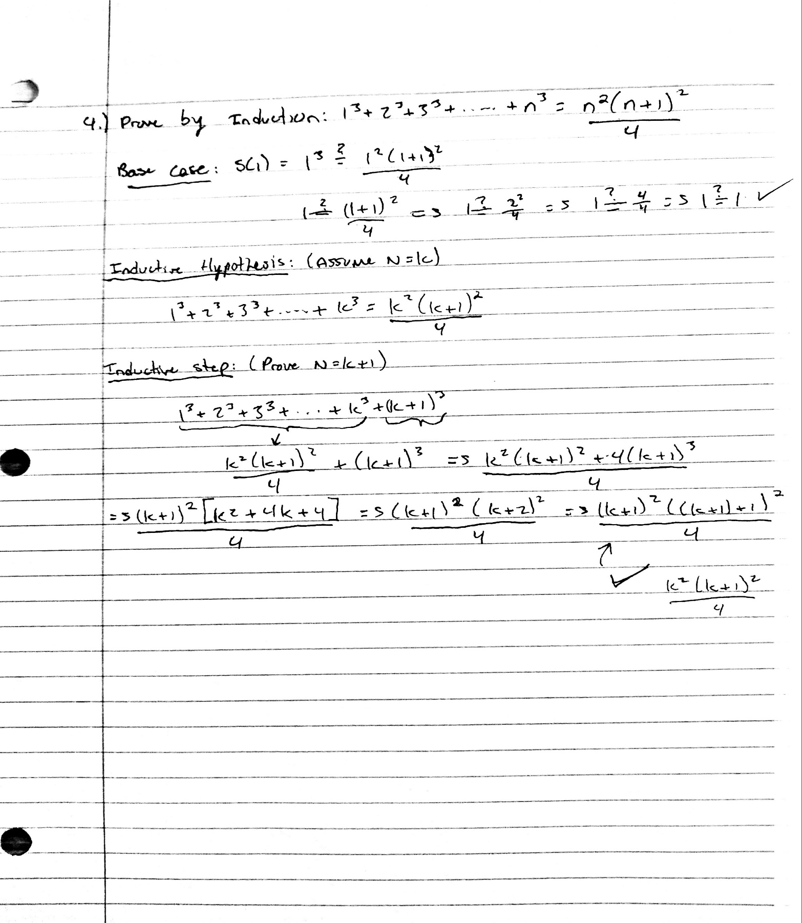

1. **Suppose your calculator only did base 10 logarithms, write an expression to compute log base 2 of 64 using log base 10.**

Using change of base formula: $\log_{a}\left(x\right)=\frac{\log_{d}\left(x\right)}{\log_{d}\left(a\right)} ∴\log_{2}\left(64\right)=\frac{\log_{10}\left(64\right)}{\log_{10}\left(2\right)}$

1. **An integer subarray is called alternating if any two consecutive numbers in it have opposite signs (i.e. one of them should be negative, whereas the other should be positive).**

**Given an array of n integers, write a pseudocode to compute for each index i, the length of the longest alternating subarray starting at i.**

x equals index i

Boolean flag equals false

while x < array length, do

if at first element of the subarray (e.g counter equals index i)

if first element is positive

flag equals true

else

flag equals false

end if

else

if current element is positive and flag is positive

exit loop

else if current element is negative and flag is negative

exit loop

else

increment counter

if current element is positive

flag = true

else

flag = false

end if

end if

increment x

end loop

output counter/display results